**LAB 1**

Q3: Find whether the given triangle is isosceles or not.

**Algorithm –**

1. Start
2. Take three sides a,b,c as input and store them in respective variables.
3. Check if (a == b or b == c or c == a)
   1. If True Go to Step 4
   2. If False Go to Step 6
4. Check if (a==b and b ==c)
   1. If True Go to Step 6
   2. If False Go to Step 5
5. Print “Triangle Is Isosceles”. Go to Step 7
6. Print “Triangle is Not Isosceles”
7. End

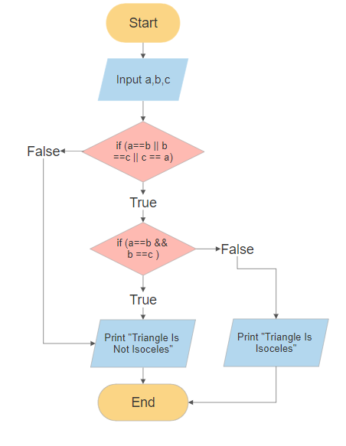

**SPARSH CHADHA**

**E18CSE179**